# 1 Algorithm Analysis

## 1.1 Algorithm performance analysis

Table 1 Comparison and improvement of R-CNN, Fast R-CNN , Faster R-CNN

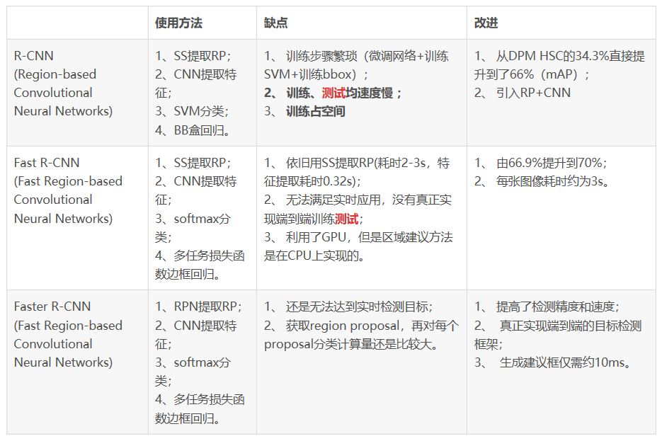

Structurally, Faster RCNN has integrated feature extraction, proposal extraction, bounding box regression (rect refinement), and classification into a single network, resulting in a large improvement in comprehensive performance, particularly noticeable in detection speed. It is especially obvious in the detection speed. Because Faster R-CNN is easy to master and has significant performance advantages, our group chose the Faster R-CNN algorithm for this keypoint detection course design.

## 1.2 Algorithm Composition and Implementation Block Diagram

Faster R-CNN consists of four parts: 1) convolutional layers (conv layers), used to extract the features of the picture, the input is the whole picture, and the output is the extracted features called feature maps 2) RPN network (Region Proposal Network), used to recommend candidate regions 3) RoI pooling, converting the different sized inputs into fixed length outputs.4) Classification and regression, the output of this layer is the final destination, outputs the class to which the candidate region belongs, and the precise location of the candidate region in the image.

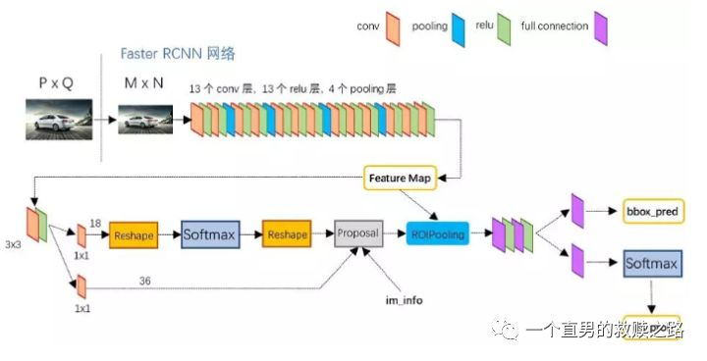

Fig. 1 Diagram of Faster rcnn implementation

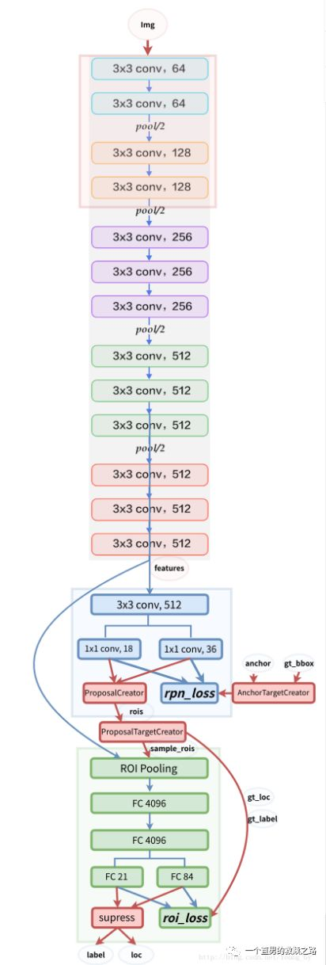

Figure 2: Fater rcnn detailed network framework